Francen World Outreach

Dear Christian Friend.
We are grateful you have invited Francen World Outreach to come and be colaborers with the local churches in reaping a harvest in your city! In order for the campaign to operate as smooth and efficient as possible, we have put together a manual that addresses our procedures, policies and purposes. It is one of FWO's priority to be good stewards of the provision God has supplied, so it is necessary that certain actions and procedures be done in order for the crusade to be a success. We have discovered if everyone understands what is expected of each other we will work better towards our common goal - reaching the lost for Jesus Christ!
We want to express our appreciation to all who are involved in the city-wide Quest For Souls campaign. Anyone who is involved is by their own voluntary free will. We understand that we are colaborers together in reaping a harvest and that we could not accomplish the task without your assistance.

I believe that every sacrifice made on your part will not go unnoticed by our precious Lord, and that God will bless every endeavor of labor of love in participating in His number one job - soul- winning!
With a Passion for Souls,
Mike Francen

Pre-Crusade Preparations
Our first step in organizing a city-wide campaign is to elect an executive committee consisting of a crusade chairman and a number of co-chairpersons. These individuals will head the committees for their respective responsibilities. An honorary chairperson is advisable in some instances. The Chairperson will be responsible to help and insure that the committee chairpersons are fulfilling their responsibilities. Examples of crusade committees: Prayer, Arrangements, Publicity, Volunteers, Finance, Women's, Technical, Choir and Follow up.
It is necessary to have Crusade stationary printed. Our Director will instruct and advise in the printing of all materials pertaining to Francen World Outreach. Anything that is printed has to have express permission and authorization before it can be used. It gives the crusade an identity and it helps in correspondence with people and parties involved with the campaign. A list of the committees and the chairpersons should be on the stationary.

Crusade Office/Committee Meeting Place:
The second step is to procure a crusade office. It would be a place to store publicity material, coordinate meetings and conduct the general operations for the crusade and its related functions. A space could be rented for a month previous to the crusade depending on cost. Only upon the Int'l Directors signed or verbal approval can the office be secured. A church or business that has the room can be used if no building can be obtained.

Grounds/stadium:
One of the keys to success in a crusade is the location, size and public familiarity of the place chosen to hold the meeting. We have found from experience not to compromise on this issue. The executive committee must make a list of the 3 best locations, based on our criteria: 1. Centrally located, 2. neutral (non- church grounds), 3. large(12,000) min. stadium), 4. Easily accessible, 5. Public awareness. The representative from FWO will want to visit these grounds.
The committee should also have made the inquiries as to the cost, availability and procedures into obtaining the sight. If the best grounds are not available, we will not conduct the crusade.
Thought must be given about the days the crusade is scheduled to insure that there is no conflicts with a previously planned event, such as a national celebration, a soccer game, national or local elections or a holiday that would keep people away from the crusade.

Budget:
FWO has provided an information sheets that will give us an estimate on the costs of the various equipment and services we need. All of this information must be obtained in order for FWO to come to the city Each one of these areas are vital to the flow of the crusade and the ministry. FWO needs to know the availability and estimated cost of this campaign before we commit to coming.

Benefits of a Crusade
.. Praise be to the Lord who daily loads us with benefits. (Psalms 68:19)

Benefits the local church receives from a city wide crusade

Unity
The crusade uses Christians from all denominations to work in the different committees giving the community an opportunity to see that cooperation and unity among us. Jesus prayed to the Father that we would be brought to complete unity so that the world may know that the Father sent Him.

Training
Hundreds of Christians from local churches and new converts will be trained and inspired to bring people to a saving knowledge of Jesus Christ through our training sessions and our Soul Winners Institute we hold in conjunction with the crusade. These men and women will be able to serve your (.-hutch and ministry in the years to come. Also Mrs. Francen will conduct a special meeting for tile women of the area, these meetings always encourage, equip, and inspire the women to go to new dimensions in their walk With the Lord.

Intercessory Prayer
Members of the local church are urged to Join in intercessory prayer for friends and relatives as well as for the people in the city The results of these prayers have a long lasting impact and the church will benefit from the changes of hearts and attitudes of those prayed for.

Renewed Zeal
People in the congregation have there spirits refreshed from the crusade in seeing and hearing the messages and miracles. This refreshing carries over to the local churches. The members tend to become more inspired to financially support their respective churches. This is a direct benefit from the meetings.

Faithfulness
People in the churches attend more faithfully following a crusade. Mike and Kim Francen encourage the believers as well as the new converts to continue in the faith and to regularly attend and support the local churches.

Exposure
Thousands of people, who have accepted Jesus Christ, in response to the message of the Gospel, will need a local church to grow in. As a participating church of the Quest for Souls campaign, opportunity will be given for you to introduce yourself and your church from the stage. This will give you and your ministry the exposure you need so the people may know when and where they might attend church.
Also, a flyer that has the local church names, addresses and service Limes will be distributed at the crusade meeting.

Campaign Committees

Prayer Committee
Hundreds of prayer partners throughout the city and surrounding area are encouraged to pray for the campaign. A prayer card is given to all the Christians reminding them to pray daily for the areas listed on the prayer card. Another aspect of the prayer program is the development of small prayer groups in homes, churches, youth locations or any other place people are willing to meet to pray We want to get as many people involved as possible. A women's prayer group or businessmen is another idea.
Prior to the beginning of the Crusade a united all night prayer service will be conducted. These services have been, in the past, held on the crusade grounds.

Counseling Committee
Many times after the meeting is dismissed for the night there are people wanting individual prayer; in need of assurance or have other spiritual needs. Counselors will -be trained in a meeting(s) hosted by the counseling committee to help minister to these people. The counselors will also help in the distribution of any follow-up material.

Telephone Committee
The aim of this effort is to extend an invitation to all homes who have a phone throughout the city on the final days preceding the opening of the "Quest for Souls" campaign. Each participating church will assume responsibility for contacting a specific section of the phone book. Organizing, coordinating, and assignments will be given to the churches from the telephone committee.

Youth Committee
In every area of crusade planning, youth can help. In prayer, volunteers, publicity, counseling, telephone and operation Andrew Activities must be planned to mobilize youth to see that they become involved in the preparations and the actual crusade meetings. A Christian youth march could be planned to draw attention to the meetings for example.

Publicity Committee
Ideas are developed and discussed concerning ways to make the public aware of the meetings. The committee will be responsible to work with the FWO. Crusade Director in banner erection, flyer distribution, auto rickshaw advertising and other avenues of informing Christians and non-Christians of the up-coming crusade. Also they will keep local congregations alert, informed and inspired to participate in all preparations.

Transportation Committee
Contacts will need to be made to the local bus authority as to arrange possible additions to bus service to the crusade sight or other arrangements to insure people getting to their homes.

Volunteer/Ushers Committee
A local person selected to chair this committee will recruit as many volunteers/ushers as they are able from the local churches, youth groups, Christian men or women colleges and high schools. A volunteer/usher meeting will be held to discuss their responsibilities and requirement committee.

Arrangements Committee
The arrangements committee will assist the FWO Crusade Director in assuring the stage area is erected and furnished in the way outlined by him and in obtaining sound equipment for the crusade. Details such as obtaining drinking water for the public, temporary AC power, stage furniture and other such things will be the responsibility of this committee.

Finance Committee
This committee, along with representatives of Francen World Outreach, is for concerned Christians who will implement ideas and opportunities to help financially off-set the budget of the campaign. Francen World Outreach feels that ample opportunity and effort should be made locally to raise financial support. Ideas like special "Quest for Souls" campaign offerings at local churches, business community involvement, fund raiser banquets and challenges to concerned groups are some avenues to accomplish this committees goal. Regardless of the local amount of funds raised for the Campaign FWO. assures that all approved expenses will be paid.

Follow-up Committee
FWO will conduct a new believers meeting during the crusade days were literature, materials and decision cards can be distributed. A suitable place should be secured for such an event. The Follow up committee also should plan on a strategy to build off the momentum of the crusade with participating churches involved to evangelize and disciple new converts.

Women's Committee
The women's committee is responsible for the women's meeting that Rev. Kim Francen would conduct. A meeting hall, sound equipment, ushers, advertisement and all other details connected with the women's conference will be handled by them. A representative from FWO will help in directing the expectations of Rev. Kim.

Advertising
One of the most important aspects of the crusade is advertising. The main purpose of advertising is to make people aware of the crusade and other events. To do this as effective and cost efficient as possible, we have provided quotation forms for the advertising chairperson to use once he has collected the information on the various costs of the different types of advertising.
There are a number of advertising techniques that run common in most crusades. Ideally, once the posters and handbills are printed, it is best to store them and all the publicity materials in one location, which is why we advise a temporary crusade office.

Posters/Handbills:
We desire to make full color posters and handbills, (see example) We will, if Possible, provide the color negatives for the printer. This simplifies things for the advertising chairperson and FWO. If not possible, we will work with the advertising chairperson in securing art work and proper layout for the poster/handbill.

Procedure
A map of the City should be purchased and the City divided into clearly marked zones. Teams sent to each zone, this will help from overlapping. Posters are to be put up, beginning 10 days prior to the crusade. If they are put up any earlier than that they are usually subject to abuse, tearing, and the elements. They should be put up with a glue fully covering the backside of the poster. Ad agencies may be used to put up the posters but always send a trusted brother with them to insure the work is being carried out. Teams from local churches may also be used to facilitate the work.
Posters should be put up in only places allowed by the local authorities. Busy intersections, turnabouts, street corners, markets, bus stands, walls, poles and businesses are examples of effective locations. They should be used liberally, but not wastefully There are times when scores of posters can be in one area and times when one is sufficient. The space and area will determine these issues. The committee chairman should insure that the allotted amount of posters are being used each day by visually checking the areas.

Handbills
The handbills are a very effective way of spreading the word about the campaign. The strategy for using this tool is varied. The distribution of the handbills should start 2 weeks before and continue up to and even during the campaign.
Once the handbills are available, enough of them should be delivered to the local churches to inform them of the crusade. Encourage them to pass out handbills in their communities and work places. This is another way to get the people involved; send them into the markets, bus station, parks, main walk ways soccer games any where people gather.

Auto Rickshaws
There are times when we use two forms of advertising at once. Normally, we hire motorized vehicles in which we place an amplifier, speaker and tape player. These vehicles go through an area of the city, the drivers stop at various locations advertising the crusade by audio tape, where volunteers pass out handbills. 4-5 of these mobile advertisers through out the city in their respected zones, Usually we send these units out 3-4 days prior to the crusades and run them through out crusade, During the crusade we discontinue the use of the tape and read a script of the miracles that happened the previous night. That script (see example) must be ready and copies made to distribute to the auto rickshaw teams in the morning previous to sending them out for the day

Banners
Banners are another effective way to inform the public of the crusade. Banners can be made in various sizes and shapes. They should be strung across important streets and intersections; ( high enough that trucks will not run into them ). Vertical banners may also be used and placed on light or telephone poles that run in the middle of the street or in places a larger banner would not work. Banners should display the venue, days, and times of the crusade and any other information that is necessary When gathering bid information, find out the prices for full color screen printing and the cost for hand painting.
A stage banner is to be made 3 meters x 31 meters (or the width of the stage).
It should read "Jesus Christ Is The Same Yesterday, Today and Forever." Heb.13:8.
This banner will go across the entire back of the stage. The banner should be erected so the bottom of the banner is approximately 10 feet off the stage.

Radio/ Television
In certain cities advertising on radio/TV will be advisable. The key is to buy the best times and days for the maximum exposure available funds. Negotiations with local media representatives on the respective channels should be carried out to insure the best value for the money allotted. Usually the best time for an audience on TV is around the late news. It is also the most expensive time. Fill out the appropriate spaces on the budget form and attach the estimate to the form.

Newspapers
Determine the costs for newspaper ads by requesting the ad be placed on the 2nd or 3rd page and at a size of 1/4 page and less. (See Example) We want as big an ad as possible. Find out the circulation of each paper and which days they go to print. This will help determine which days to choose prior to the crusade for advertising. Typically, we advertise in the paper the Sunday prior to, the day before and the first day of the crusade. Use the handbill and the enclosed picture of Rev. Mike Francen for the layout of the ad. (See Example)

Billboards
Contact the billboard holders and collect bids on renting a board for a month prior to the crusade. See picture for example. Use the handbill layout for billboard design.

Other
In every city or area there are other ways of getting the word out. We encourage ideas, handbills can be dropped from an airplane, parades organized to march through areas of the city to pass out handbills and balloons, sing, play music, and more all to attract attention to the crusade. Stuff newspapers with handbills. Go into rural areas and put up posters and banners in their community.

Sample Press Release/Article
American evangelist Mike Francen has planned a campaign to bring good news and hope to the citizens of (name of city.) Rev. Francen has visited over 45 nations of the world proclaiming the Gospel of Jesus Christ. Hundreds of thousands have heard and seen the love of God manifested in their lives and bodies in his meetings. Rev. Francen has also authored many challenging and inspiring books; his organization supplies tons of Christian literature and help to the national churches by providing tools necessary for serving their communities and nations.
The evangelist meeting are marked by displays of physical healing and large crowds. The blind have received their sight; the deaf have heard and the lame walk and the people have hope restored to them. Crowds in excess of 100,000 people have come to participate in the meetings. The public is cordially invited to attend and expect a miracle!

Example of Radio Promo
The citizens of ________ are cordially invited to come see and hear American evangelist Mike Francen. Rev. Mike has been to nearly 50 countries around the world. Hundreds of thousands have witnesses and experienced the miracle working power of God. Lives have been changed, the blind, deaf and lame healed and hope restored to a hurting people. in association with the council of churches, Rev Mike will be conducting meetings at the ______________ stadium (or grounds), from 6:30-9:00 PM the 21st through the 26th of March. Come and expect a miracle.
(30 seconds)

Sample Newspaper Ads
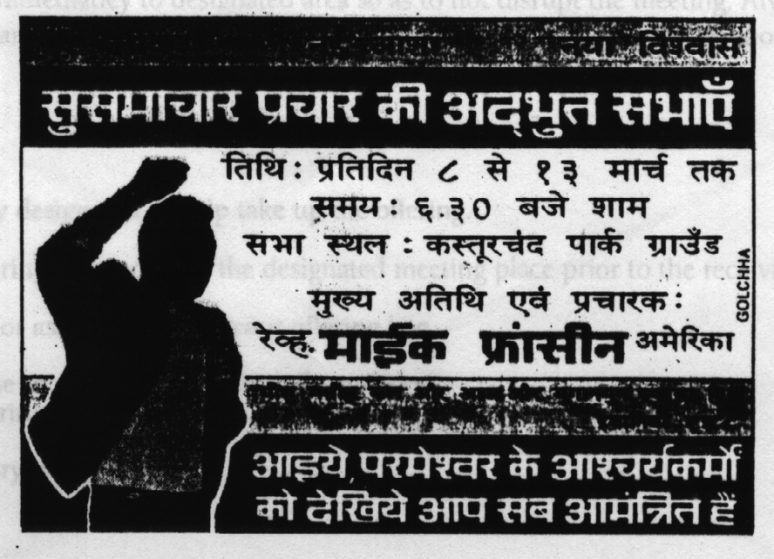
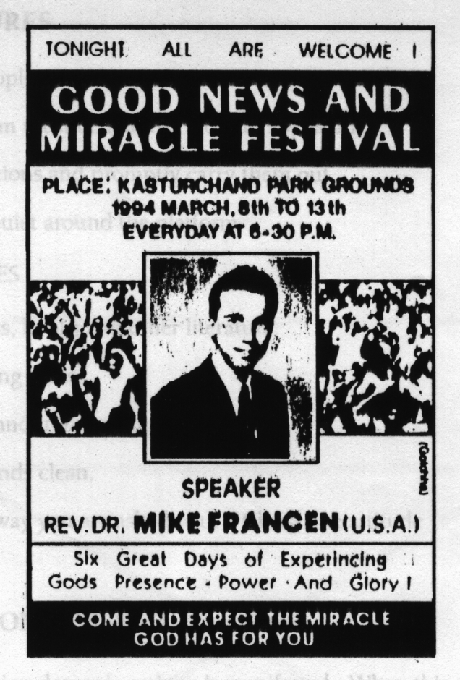

Volunteer Training

PLATFORM PROCEDURES
1. Keep all unauthorized people off the stage area.
2. Volunteers around platform must he mature older in appearance.
3. Listen carefully to instructions and promptly carry them out.
4. Encourage folks to keep quiet around the platform

GENERAL RESPONSIBILITIES
1. Distribute materials Bibles, books and other literature.
2. Direct individuals to seating areas.
3. Help in setting up chairs and in removing them.
4. Keeping the crusade grounds clean.
5. Be willing to help in any way you are asked with a Christ like attitude
6. Collect decision cards.

HANDLING THE DEMON POSSESSED
Sometimes during the campaign demonic activity is manifested. When this Occurs, two volunteers shall escort the afflicted immediately to designated area so as, to not disrupt the meeting. Always conduct yourself in a Christian manner. Do not try to help or minister to them. We will let those in the deliverance tent do this.

USHERS
1. You are specifically designated to help take up the offering.
2. Collect your offering bag and be at the designated meeting place prior to the receiving of the offering.
3. Do not be timid or ashamed to pass your offering bag.
4. Take enough time to get to all of the crusade attendees.
Return your offering bag to the volunteer in charge or the crusade director.
5. Must attend every night.

Arrangement Committee
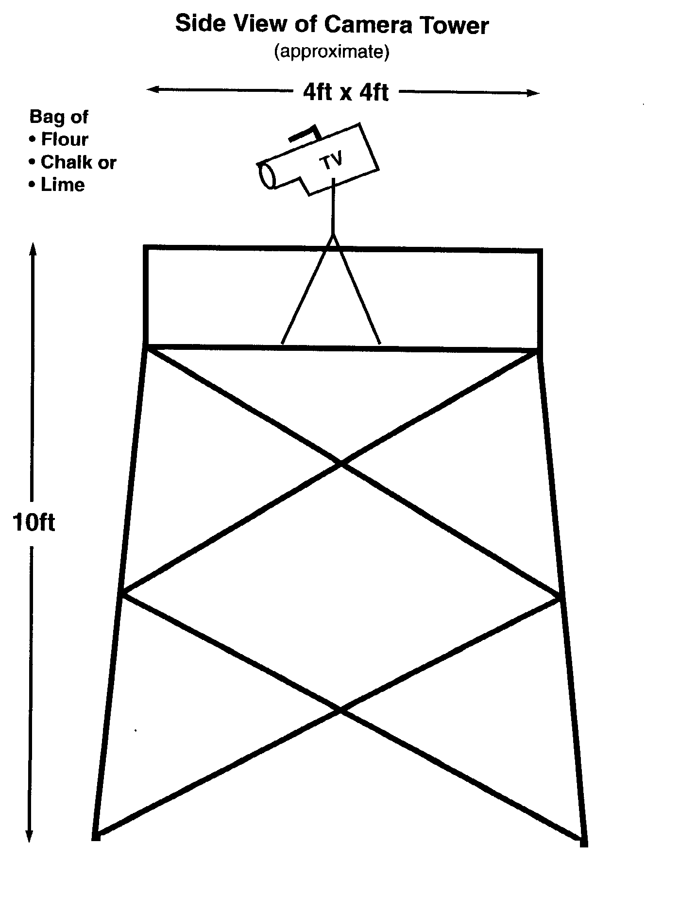

Arrangement Committee
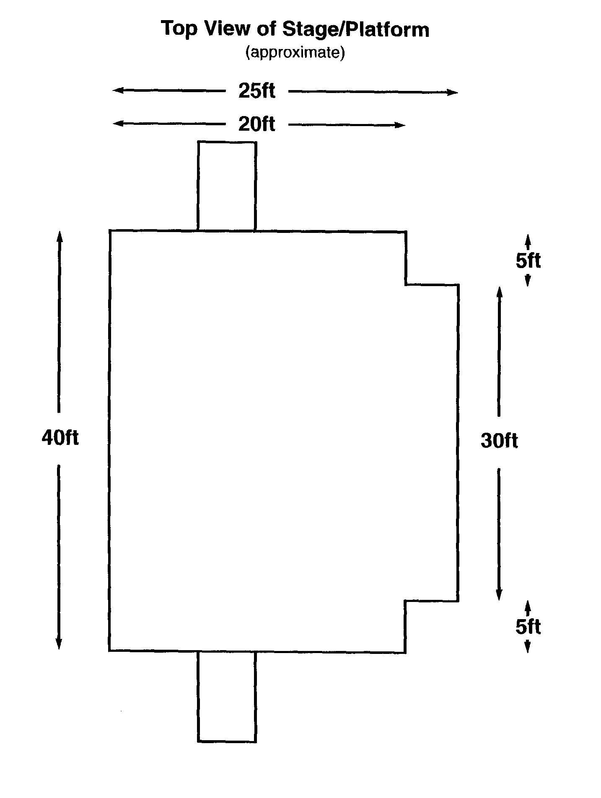

Information Sheet
We thought we should go over the way a typical crusade night progresses. This will inform the members of the different committees of what to expect. In doing this our aim is that everyone will be of the same mind so things may run decently and in order.

Stage Procedure
The crusade begins with opening prayer and then the choir and hand members will minister to the public, this begins at 6:30 pill.
The choir, hand members, counselors and volunteers should arrive at the crusade grounds 45 minutes prior to the start of the music ministry. The music ministry will continue until 7:30 p.m. Then announcements concerning the times, dates, book sales or any crusade related matters will he given to the public. Once these announcements are completed the announcer will invite a local pastor or Christian leader for a Bible reading. After the reading, that pastor will invite a fellow minister to pray for that nights meeting. These preliminaries should be completed promptly by 7:45 p.m. at which time the microphone will be given to Rev. Mike Francen. If there is ample time left after the prayer (at least 5 minutes) one final song may be sung. Rev. Mike will preach approximately 45 minutes. After which a call to receive Jesus as Lord will be given then a miss prayer for the sick will he offered. Testimonies of what God has done to the people oil the grounds will then be shared from the stage. The meeting will conclude at approximately 9:00 p.m. or shortly there after.
Counselors and ministers from the local churches should stay after the conclusion of the meeting to pray for those who request it
Occasionally instead of the music ministry continuing until 7:30 p.m. a short teaching will begin at 7:00 p.m. and conclude at 7:30 p.m. All participants in the different committees must be willing and flexible to cooperate with the crusade director if the program format is changed.
Times and procedure may very from country to country

FWO Follow-up Program
Revs. Mike and Kim are committed to do everything they can to insure that new believers get in Introduction into the Christian way of life, Their desire is to make available opportunities and materials to those who decided to follow Jesus We have listed what we do in our follow up program when ever possible:

Distribute a local Church flyer
On tile last few flight-, of file crusade a flyer will be disbursed containing file participating local churches name, address and pastors nitric, Also oil the Final night of tile crusade in opportunity is given to tile participating pastors to introduce themselves and their church or ministry, exposing them to the flew believers.

Distribute New Testaments
When ever possible, oil the last few flight,-, of the crusade, members from the various committees will distribute New Testaments to those attending as they enter tile grounds. This is a gift that keeps on giving and will provide them with file means to grow in the things of God.

Distribute New Life books
Along with tile New Testaments, Rev. Mike has authored a book he wants to give the attendees, of the crusade. This book deals with issues of the new birth and gives foundation teaching that new Christians need to begin to walk the new life.

Distribute Tracts
Francen World Outreach has a number of tracts that are available in several languages that can be distributed for the purposes of evangelism and basic Gospel knowledge.

A Soul Winners Institute
A one day "Soul winners Institute" is conducted after the closing of the crusade.
Three or more teaching sessions, are conducted at different times of the day, encouraging, training and inspiration through the scriptures to serve tile Lord. The Francen's as well as their staff will be teaching these sessions. At times books will be offered, a small fee for registration will be required to attend.

New Believers Classes
During the crusade day a new believers meeting will be held to teach foundational truths of Gods Word to equip the new believers in their Christian walk.

Local Spiritual Growth Seminar
The local Christian leadership will hold weekly meetings at a neutral location(s) for 3-4 weeks after The Quest for Souls, Campaign has ended. Focusing on involvement of the new Christians in local churches. This will also give opportunity for continued follow-up for those who attended the Soul Winners Institute,

Testimonials
Evangelists Mike and Kim Francen form a remarkable world evangelism and church-building team in this generation. Their ministries of conducting mass miracle crusades, followed by Bible training seminars have produced remarkable results in nearly 40 countries.
Their commitment to follow-up with great stockpiles of Bibles and a wonderful assortment of faith teaching books and tracts have sown the Gospel seed in multitudes of people. Their program to provide sold winning tools, to the national believers and church leaders abroad has facilitated enormous extensions of their evangelism ministries through national churches, in hundreds of areas where they may never be able to go there personally.
Their program to build national churches and to solidify the converts from their mass crusades into strong soul winning centers is similar to the ministry of Paul the apostle.
We commend the ministries of Mike and Kim Francen, and it seems clear to us that any financial investment in the work of this young couple is a valuable investment in the work that is nearest God's heart, reaching the unreached, loving the unloved.
Drs. T.L. and Daisy Osborn
Osborn Foundation

On behalf of myself and Kenneth Copeland Ministries, we congratulate you on your five years of service to God and the people of Africa, India, and the world. It is always exciting for us to witness the faithfulness of God's, ministers.
As a recipient of support from this ministry since 1986, careful attention his been paid to the fruit of your labor. The integrity and effectiveness of your ministry is evident in the number of people translated into the kingdom of our Lord Jesus Christ.
Our lives are inspired through our fellowship with you.
Rev. Barry Tubbs
Kenneth Copeland Ministries
I am thrilled to he a supporter of Mike Francen. I have never seen a Young man with such potential to reach the world. I heartily. recommend him to you.
Pastor Rick Shelton
Life Christian Center

This letter is my personal recommendation for Rev. Mike Francen and the anointed ministry to which he has been called
Mike expresses a deep commitment to selling the captive free through preaching the Word of God and through the operation of the gifts of the Holy Spirit. Through his Ministry, many have experienced the power of God.
I truly believe that God Will use Mike in a mighty way these last days. Proverbs 18:6 declares that man's gift will make room for him and bring him before great men I believe this is being manifested in this ministry
Dr. Jerry Savelle
Jerry Savelle Ministries

Rev. Mike Francen is my son in ministry as Timothy was to St. Paul in the Bible days. Evangelist Francen is a wonderful talented preacher with gifts of the Holy Ghost and signs and wonders following.
I have no fear whatsoever to recommend Mike to any ministry that needs revival and miracles in the now! He comes with my love and prayers.
Dr. Benson Idahosa
Idahosa World Ministries

FROM ABROAD
Brother Mike Francen was used by God as a great instrument. Between 80,000 and 100,000 people filled the grounds the last night of the crusade. People sat for hours some from even on top of houses to hear the message.
Hindus from the area came to disrupt tile meeting but on hearing the message and seeing tile miracles, were transformed as they accepted Jesus. So many people were healed of paralysis, deafness, blindness, etc., and came to the platform to testify of miracles.
This tri-cities healing crusade was a grand success! Though it was harvesting season, thousands left their fields and came to the crusade and accepted Jesus. Thousands were saved and healed, and God gave a grand success!
Rev. PV Purushotfam
Bishop of more than 100
Pentecostal churches in India

Advertising Budget Form

Quantity | Price | Unit Price | No. Colors | Total | Comments | Comp Date
POSTER
HANDBILLS
WOMEN'S FLYERS
CHURCH INFO.FLYERS
TRACTS
DECISION CARDS
PRAYER CARDS
POSTER LABOR
BANNERS
STAGE BANNER
BILLBOARDS

 | Number of Spots | Days | Length of Spots | Fee per Spot | Total Cost
TV
RADIO
NEWSPAPER

* Please fill out completely and attach all bids to this form.

EQUIPMENT AND SERVICE BUDGET FORM

 | COMMENTS | TOTAL
SOUND SYSTEM: rent
Horn speaker (6-12)
Box speakers
Mixer board (8 channels min.)
Watts available approx. 5000)
Amplifiers
Microphones (6 8)
Stage monitors
Wire, Cords
Tape recorder and duplicator (for messages)
Sound crew labor charge
STAGE:
General description: Approximately 30' x 25'x 9' With walking ramps or steps on both sides
Carpentry and labor charge
Lumber and material cost
Transportation of materials and people
ELECTRICAL:
Power book tip charge from city or facility for AC current
Generator 62 KV
Diesel per litre
Generator operator labor charge
Halogen lights (1000 watts a few 500 are also needed) (60-75 required for night crusade, very important) cost. to rent or purchase
2-5 ft. poles to be placed on the grounds approx. 30 of them) If there are no existing poles on the grounds or stadium (rent or purchase)
Electrician labor charge
Transportation of material and people

 | COMMENTS | TOTAL
TRANSPORTATION:
Cost for renting 1 or 2 car and driver per week
CHOIR
Although the choir is important to the crusade there is no budget allotted for it except for song sheet duplication and other miscellaneous cost. This is a voluntary ministry.
VOLUNTEERS AND USHERS
As a volunteer and usher we ask that they find there own way to the meeting and not expect funds for a ride or transportation to be provided from Francen World Outreach or the executive committee.
GROUND/STADIUM FEE:
SECURITY FEE
LITERATURE:
New Testaments
Book of John

Counselling Slip  Miracle Healing & Salvation Crusade  Name____________________________________  Address __________________________________  _________________________________________  Date/New Birth_____________________________  Give Diagram of your location on the back of this sheet. (P.T.O.)  Who to contact for you_______________________  _________________________________________  First time receiving Christ? Yes ( ) No ( )  Rededication? Yes ( ) No ( ) | Counselling Slip  Miracle Healing & Salvation Crusade  Name____________________________________  Address __________________________________  _________________________________________  Date/New Birth_____________________________  Give Diagram of your location on the back of this sheet. (P.T.O.)  Who to contact for you_______________________  _________________________________________  First time receiving Christ? Yes ( ) No ( )  Rededication? Yes ( ) No ( )

You are a vital part  of the  Francen World Outreach  "Quest for Souls"  campaign.  The Francens are honored to be invited to your city by local pastors and Christian leaders. We have conducted crusades encompassing the globe. One thing we have learned and experienced is that we need your help to insure a successful meeting.  The Bible teaches us that we are all part of the body of Christ (1 Cor. 12.27) and that He has given us abilities to work in the advancing of His kingdom. We need to combine our God given talents and strengths as well as joining together in prayer for a great harvest of souls .  Will you consider Joining us in our Quest for Souls? You are a vital part to the successes of this outreach. Please check one or more of the areas of ministry you would like to participate in, listed on the back of the page.  Mike Francen | You are a vital part  of the  Francen World Outreach  "Quest for Souls"  campaign.  The Francens are honored to be invited to your city by local pastors and Christian leaders. We have conducted crusades encompassing the globe. One thing we have learned and experienced is that we need your help to insure a successful meeting.  The Bible teaches us that we are all part of the body of Christ (1 Cor. 12.27) and that He has given us abilities to work in the advancing of His kingdom. We need to combine our God given talents and strengths as well as joining together in prayer for a great harvest of souls .  Will you consider Joining us in our Quest for Souls? You are a vital part to the successes of this outreach. Please check one or more of the areas of ministry you would like to participate in, listed on the back of the page.  Mike Francen

YES I WANT TO BE A VITAL PART OF THE QUEST FOR SOULS CAMPAIGN  PRAYER You and your fellow prayer partners will pray for all aspects of the crusade We consider this committee to be the most important  COUNSELING/FOLLOW-UP will be provided will be able to lead A soul to Jesus and to help people receive from the Lord. Pastors will be present to assist counselors if needed.  PUBLICITY You will distribute handbills, erect banners and posters. and assist other publicity related  VOLUNTEERS/USHERS These individuals will prepare the crusade grounds set up, chairs. lay carpets and receive offerings and direct the public.  TELEPHONE The people in this committee will invite people to the crusade by telephone  BUDGET COMMITTEE People in this committee will encourage others to financial participation in meeting the expenses of me campaign.  NAME__________________________________________  ADDRESS_______________________________________  CITY_______________ PHONE _____________________  HOME CHURCH NAME ____________________________  NOTE: PLEASE FILL OUT AND GIVE TO AN USHER WHEN THE COMMITTEE MEETS | YES I WANT TO BE A VITAL PART OF THE QUEST FOR SOULS CAMPAIGN  PRAYER You and your fellow prayer partners will pray for all aspects of the crusade We consider this committee to be the most important  COUNSELING/FOLLOW-UP will be provided will be able to lead A soul to Jesus and to help people receive from the Lord. Pastors will be present to assist counselors if needed.  PUBLICITY You will distribute handbills, erect banners and posters. and assist other publicity related  VOLUNTEERS/USHERS These individuals will prepare the crusade grounds set up, chairs. lay carpets and receive offerings and direct the public.  TELEPHONE The people in this committee will invite people to the crusade by telephone  BUDGET COMMITTEE People in this committee will encourage others to financial participation in meeting the expenses of me campaign.  NAME__________________________________________  ADDRESS_______________________________________  CITY_______________ PHONE _____________________  HOME CHURCH NAME ____________________________  NOTE: PLEASE FILL OUT AND GIVE TO AN USHER WHEN THE COMMITTEE MEETS

USHER | USHER
USHER | USHER
EXECUTIVE  COMMITTEE | EXECUTIVE  COMMITTEE
EXECUTIVE  COMMITTEE | EXECUTIVE  COMMITTEE

